EXPERIMENT 5
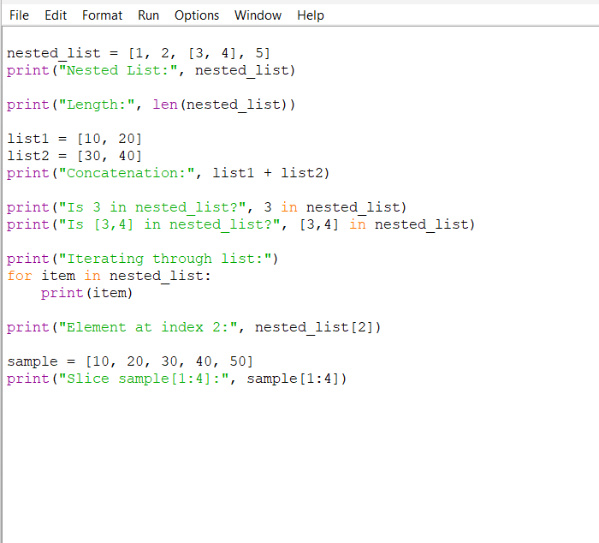
OUTPUT
